**A Comparison of Solving the Poisson Equation Using Different Numerical Methods in MATLAB**

**MECE 5397- Scientific Computing**

**Project A – Poisson Equation AP02-1**

Luis Espinoza, 1226327

Friday May 5th, 2017

**Abstract**

**Mathematical Statement of Problem**

In this report, we will test various numerical methods to solve the Poisson Equation. The Poisson equation is an elliptic Partial Differential Equation (PDE) that is linear and has constant coefficients. The Poisson equation is used to model phenomena such as the potential field caused by a given charge or mass density distribution.

We will test the numerical methods on a Poisson equation with 3 nonhomogeneous, Dirichlet boundary conditions, 1 homogenous, Neumann boundary condition, and a right-hand side function F(x,y).

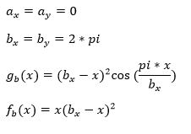

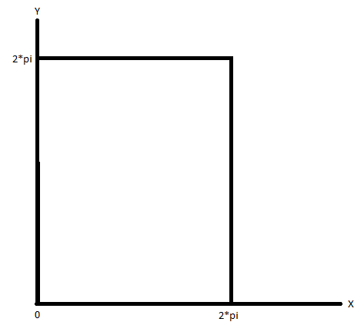

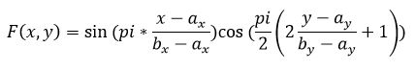

**Discretized Version of the Equation**

The partial derivatives in the PDE are approximated by linear combinations of function values at the grid points. The second-order center difference approximation is applied to both the x and y second derivatives at all points in the mesh.

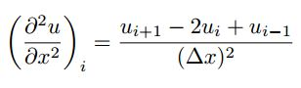

As a result, the approximated x and y second derivatives of u at a given mesh point (i, j) are given below through the evaluation of u at (i+1, j), (i-1, j), (i, j+1), and (i, j-1).

After rearranging the above equation, the discretized Poisson equation is,

Where ∆x=∆y=h is the grid spacing between nodes. This equation will be rearranged for ui,j=… later depending on the numerical method.

A quick note must be made about the discretization of the Neumann boundary condition.

Using the second-order center difference approximation to approximate the x partial derivative, the following discretization is achieved.

Simplify

This is substituted in for the Neumann boundary condition in the numerical method.

**Description of Numerical Methods Analyzed**

***Gauss-Seidel Method***

The Gauss-Seidel method is a classical iterative method. It will be used to solve the linear system of equations presented in the previous section. The pseudocode for the method is shown below.

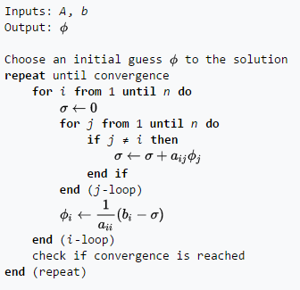

Figure 1: Gauss-Seidel Method Algorithm, Wikipedia

The method starts with a guess for the solution. In the case of our Poisson Equation project, we assumed that all interior nodes (2:Nx-1 and 2:Ny-1) are initially zero. Then, the linear system of equations is solved using the initial guess and the error in relation to the previous value of the solution is calculated.

The process continues until convergence is obtained by the numerical method. Convergence is obtained when the maximum error is less than the user-input tolerance (typically 1e-06).

To solve for ui,j in MatLAB, the discretized equation is rearranged to the following form.

***Successive Over-Relaxation Method***

The SOR method is another classical iterative method quite similar to the Gauss-Seidel method but expected to result in faster convergence. It will be used to solve the linear system of equations presented in the previous section. The pseudocode for the method is shown below.

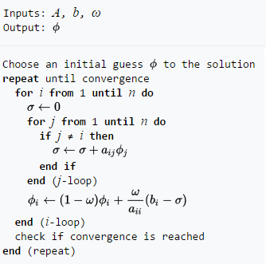

Figure 2: SOR Method Algorithm, Wikipedia

The method starts with a guess for the solution. In the case of our Poisson Equation project, we assumed that all interior nodes (2:Nx-1 and 2:Ny-1) are initially zero. Then, the linear system of equations is solved using the initial guess. The difference with the Gauss-Seidel method is that a SOR coefficient (B) must be included. The coefficient is bounded by 1<B<2. For the case of our Poisson Equation, a value of B=1.5 was used. Finally, the error in relation to the previous value of the solution is calculated.

The process continues until convergence is obtained by the numerical method. Convergence is obtained when the maximum error is less than the user-input tolerance (typically 1e-06). To solve for ui,j in MatLAB, the discretized equation is rearranged to the following form.

**Technical Specifications of Computer Used**

The machine used for this project is located at the University of Houston Engineering Computing Center. The machine is an Intel ® Xeon ® CPU E5620 @ 2.40GHz with 1 core/CPU and a current CPU clock frequency of 2394 MHz (max CPU clock frequency of 2660 MHz). The machine has 64 memory channels, a DRAM total width of 32 bits, and a total DRAM per CPU of 16384 MB.

* RAM - 8 GB
* Hard Drive - 500 GB
* Graphics Card - any with DisplayPort/HDMI or DVI support - desktop only
* Monitor – Dell OptiPlex widescreen LCD with DisplayPort/HDMI or DVI support

**Results**